**DIGITAL SIGNAL PROCESSING LAB EXPT.3**

**Z-TRANSFORMs**

**NIKHIL ROUT**

**22BEC1020**

**AIM: To perform the following tasks on Z-Transform, Poles and Zeros:**

**➢ Plotting Stable, Unstable and Marginally Stable Versions of Z-Transform graphs for the given system 𝑥(𝑧)= 1−1.6180𝑧−1+𝑧−2 1−1.5161𝑧−1+0.8781𝑧−2**

**➢** **Compute Poles, Zeros and infer the Stability of the given system:**

**𝐻(𝑧)= 1+3𝑧−1+2𝑧−2+3𝑧−3 1+𝑎𝑧−1+𝑏𝑧−2+𝑐𝑧−3+𝑑𝑧−4 where a, b, c & d refer to the Register Number: 22BECabcd**

**➢ Determine the number of ROCs of the above done H(z) system and show all possible ROCs and infer if DTFT exists**

**➢ Identify an Unstable System and determine the Partial Fraction Expansion of a Rational Z-Transform, and Determine its Inverse Z-Transform.**

1. **Plotting Stable, Unstable and Marginally Stable Versions of Z-Transform graphs for the given system 𝑥(𝑧)=1−1.6180𝑧−1+𝑧−2 1−1.5161𝑧−1+0.8781𝑧−2**

clc

clear all

close all

b1=[1 -1.6180 1];

a1=[1 -1.5161 0.8781];

[Z,P,K] = tf2zp(b1, a1);

figure(1);

zplane(b1, a1);

set(gca,'fontsize',13,'fontweight','bold');

[HZ1,HP1,HT1]=zplane(b1,a1);

set(findobj(HZ1,'Type','line'),'color','g','linewidth',2);

set(findobj(HT1,'Type','line'),'color','b','linewidth',2);

set(findobj(HP1,'Type','line'),'color','r','linewidth',2);

title('Pole-Zero Plot: Stable System','fontsize',15);

grid on;

b1=[1 -1.6180 1];

a1=[1 -1.5161 1.8781];

[Z,P,K] = tf2zp(b1, a1);

figure(2);

zplane(b1, a1);

set(gca,'fontsize',13,'fontweight','bold');

[HZ1,HP1,HT1]=zplane(b1,a1);

set(findobj(HZ1,'Type','line'),'color','g','linewidth',2);

set(findobj(HT1,'Type','line'),'color','b','linewidth',2);

set(findobj(HP1,'Type','line'),'color','r','linewidth',2);

title('Pole-Zero Plot: Unstable System','fontsize',15);

grid on;

b1=[1 -1.6180 1];

a1=[1 -1.5161 1];

[Z,P,K] = tf2zp(b1, a1);

figure(3);

zplane(b1, a1);

set(gca,'fontsize',13,'fontweight','bold');

[HZ1,HP1,HT1]=zplane(b1,a1);

set(findobj(HZ1,'Type','line'),'color','g','linewidth',2);

set(findobj(HT1,'Type','line'),'color','b','linewidth',2);

set(findobj(HP1,'Type','line'),'color','r','linewidth',2);

title('Pole-Zero Plot: Marginally Stable System','fontsize',15);

grid on;

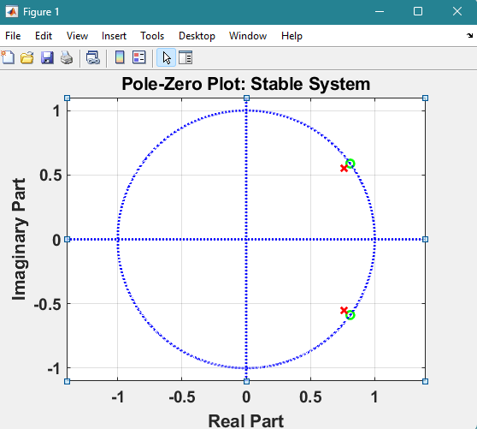

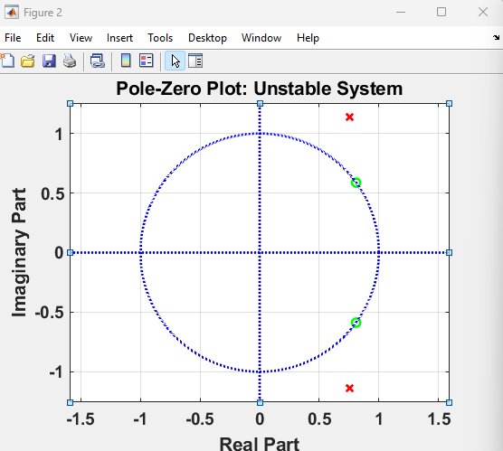

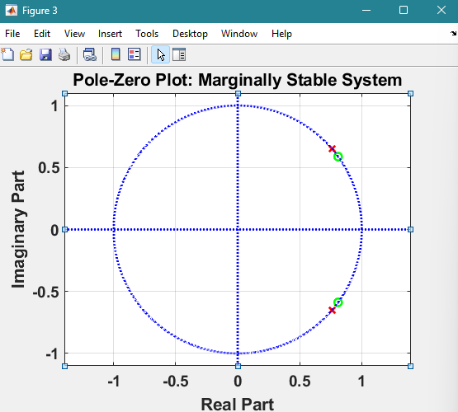

1. **Compute Poles, Zeros and infer the Stability of the given system: 𝐻(𝑧)= 1+3𝑧−1+2𝑧−2+3𝑧−3 1+𝑎𝑧−1+𝑏𝑧−2+𝑐𝑧−3+𝑑𝑧−4 where a, b, c & d refer to the Register Number: 22BECabcd**

b1 = [1 3 2 3];

a1 = [1 1 0 2 0];

[Z1, P1, K1]= tf2zp(b1,a1);

figure(1);

zplane(b1,a1);

set(gca,'fontsize',13,'fontweight','bold')

[HZ1, HP1, HT1] = zplane(b1,a1);

set(findobj(HZ1,'Type','line'),'Color','g','linewidth',2);

set(findobj(HT1,'Type','line'),'Color','b','linewidth',2);

set(findobj(HP1,'Type','line'),'Color','r','linewidth',2);

title('Pole-Zero Plot: Register 1020: UNSTABLE', 'fontsize',15);

grid on;

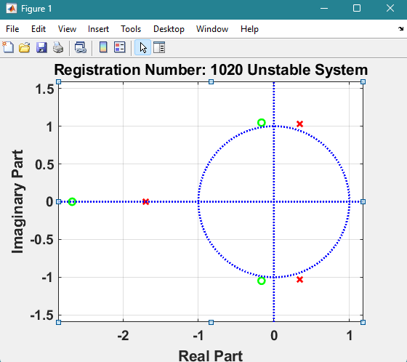

1. **Determine the number of ROCs of the above done H(z) system and show all possible ROCs and infer if DTFT exists**

b1 = [1 3 2 3];

a1 = [1 1 0 2 0];

[Z1, P1, K1]= tf2zp(b1,a1);

figure(1);

zplane(b1,a1);

set(gca,'fontsize',13,'fontweight','bold')

[HZ1, HP1, HT1] = zplane(b1,a1);

set(findobj(HZ1,'Type','line'),'Color','g','linewidth',2);

set(findobj(HT1,'Type','line'),'Color','b','linewidth',2);

set(findobj(HP1,'Type','line'),'Color','r','linewidth',2);

title('Pole-Zero Plot: Register 1020', 'fontsize',15);

grid on;

poles = P1

zeros = Z1

K = K1

M = abs(P1);

N = max(M)

if(N<1)

fprintf('DTFT exists \n')

else

fprintf('DTFT doesn’t exist \n')

end

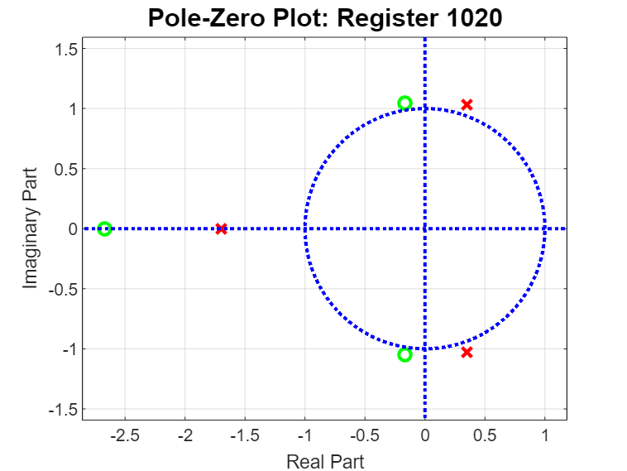

**Command Window**

poles =  
  
 0.0000 + 0.0000i  
 -1.6956 + 0.0000i  
 0.3478 + 1.0289i  
 0.3478 - 1.0289i  
  
  
zeros =  
  
 -2.6717 + 0.0000i  
 -0.1642 + 1.0469i  
 -0.1642 - 1.0469i  
  
  
K =  
  
 1  
  
  
N =  
  
 1.6956  
  
DTFT doesn’t exist

1. **Identify an Unstable System and determine the Partial Fraction Expansion of a Rational Z-Transform, and Determine its Inverse Z-Transform.**

syms z

b1 = [1 3 2 3];

a1 = [1 1 0 2 0];

[Z1, P1, K1]= tf2zp(b1,a1);

[H,T] = impz(b1,a1);

[R,P1,K1] = residuez(b1,a1);

ZT = ztrans(P1,z)

IZT = iztrans(ZT,z)

figure(1);

zplane(b1,a1);

set(gca,'fontsize',13,'fontweight','bold')

[HZ1, HP1, HT1] = zplane(b1,a1);

set(findobj(HZ1,'Type','line'),'Color','g','linewidth',2);

set(findobj(HT1,'Type','line'),'Color','b','linewidth',2);

set(findobj(HP1,'Type','line'),'Color','r','linewidth',2);

title('Pole-Zero Plot: Register 1020: UNSTABLE', 'fontsize',15);

grid on;

poles = P1

zeros = Z1

K = K1

M = abs(P1);

N = max(M)

if(N<1)

fprintf('DTFT exists \n')

else

fprintf('DTFT doesn’t exist \n')

end

**Command Window**

ZT =  
   
 -(954549633243933*z)/(562949953421312*(z - 1))  
(z*(3132797438580975/9007199254740992 + 4633538628349305i/4503599627370496))/(z - 1)  
(z*(3132797438580975/9007199254740992 - 4633538628349305i/4503599627370496))/(z - 1)

IZT =  
   
 -954549633243933/562949953421312  
3132797438580975/9007199254740992 + 4633538628349305i/4503599627370496  
3132797438580975/9007199254740992 - 4633538628349305i/4503599627370496

**Output Verification**

